**PRIME NUMBR OR NOT**  
  
**AIM:**To write an assembly language program to implement prime number using 8085 processor.  
**ALGORITHM:**  
1)   Start the program by loading a register pair with address of 1st number.  
2)   Copy the data to another register pair.  
3)    Load the second number to first register pair.  
4)    Subtract the two register pair contents.  
5)    Check for borrow.  
6)    Store the value of difference and borrow in memory locations.  
7)    End.   
**PROGRAM:**

LXI H,8100H

MOV A,M

MVI C,00

MOV D,A

MOV E,A

L2: MOV B,D

L1: CMP B

JC LABEL

SUB B

JNZ L1

LABEL: CPI 00

JNZ SKIP

INR C

SKIP: MOV A,E

DCR D

JNZ L2

MOV A,C

STA 8101H

HLT

INPUT:

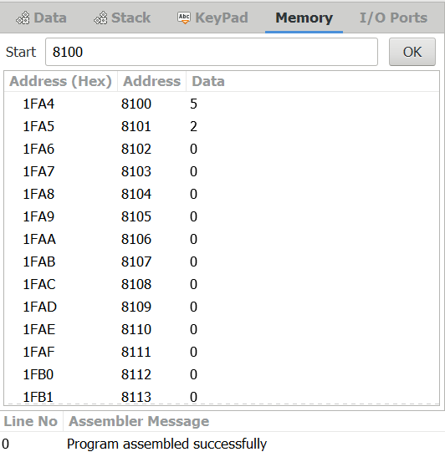

OUTPUT:

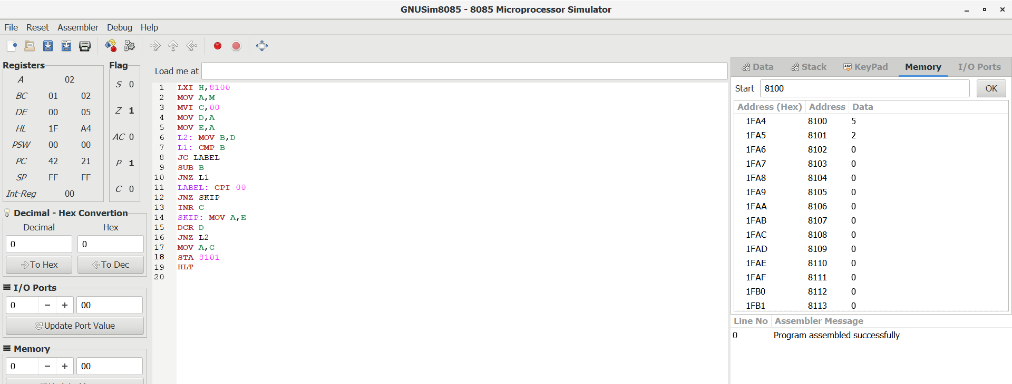

RESULT:

Thus the program was executed successfully using 8085 processor.